Step1: Open the Protégé Tool

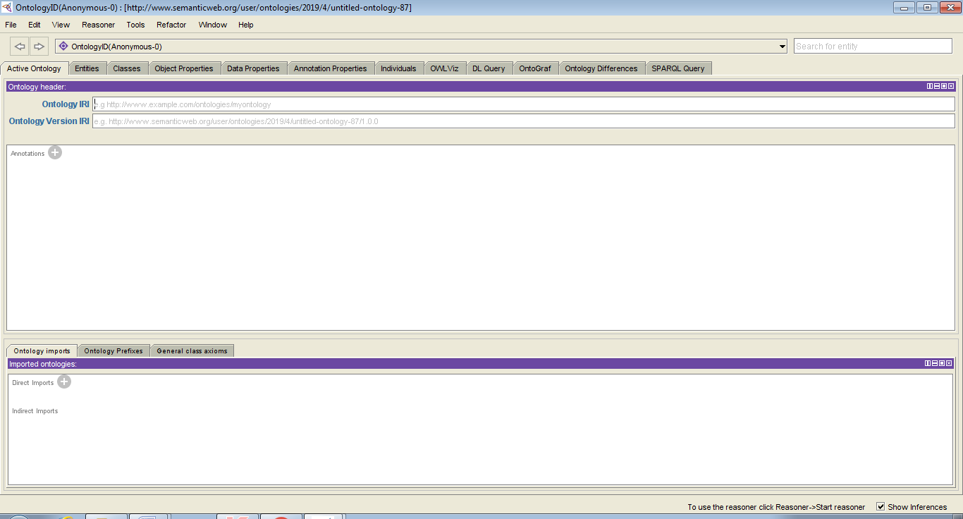

Step 2: import the .owl file in Protégé Tool

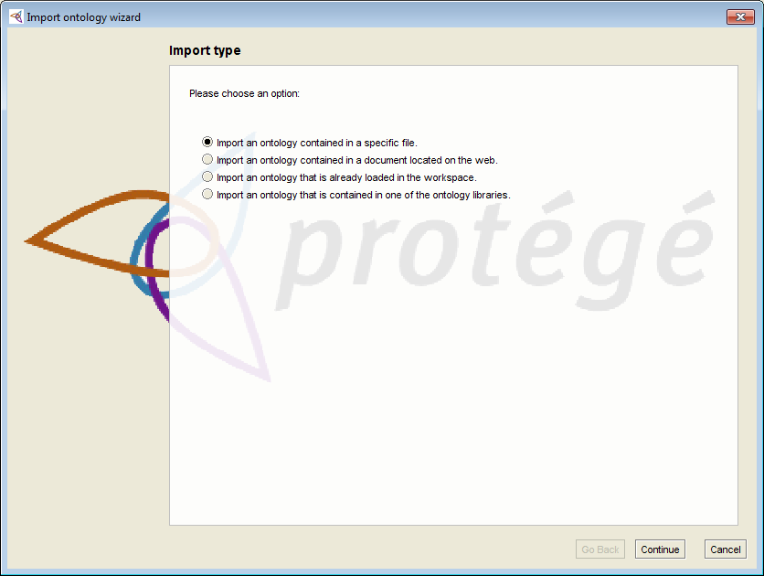

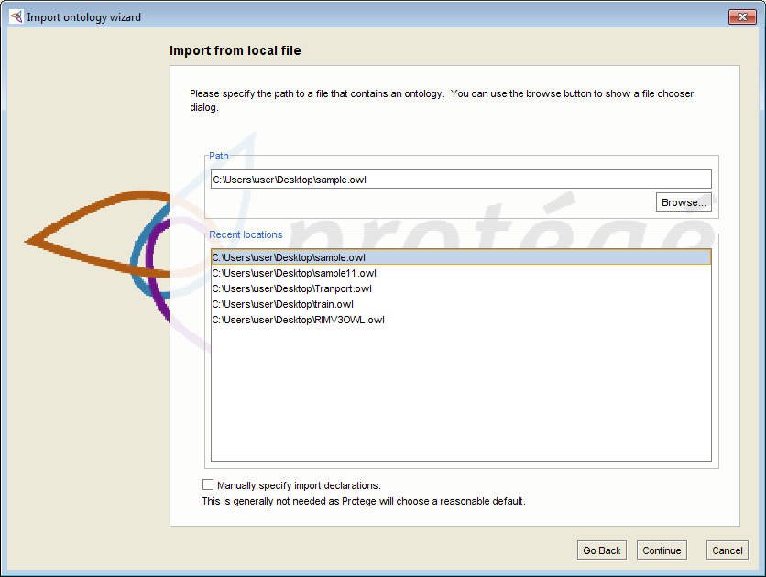

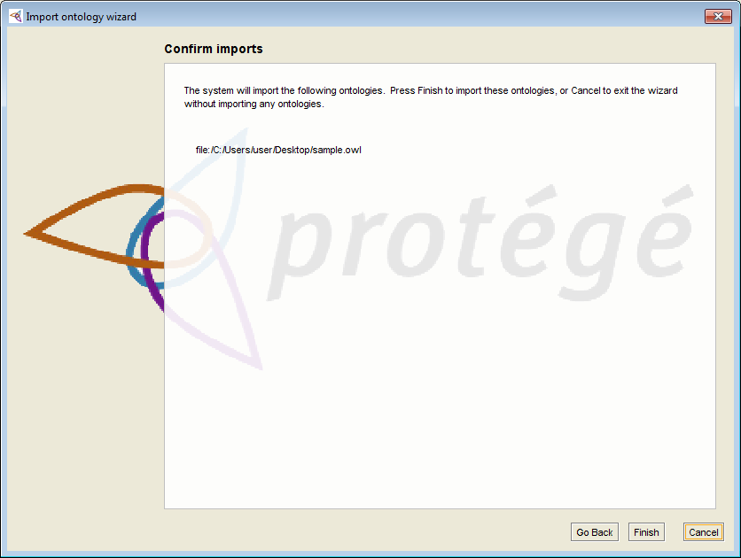

Step 3: get the ontology prefix

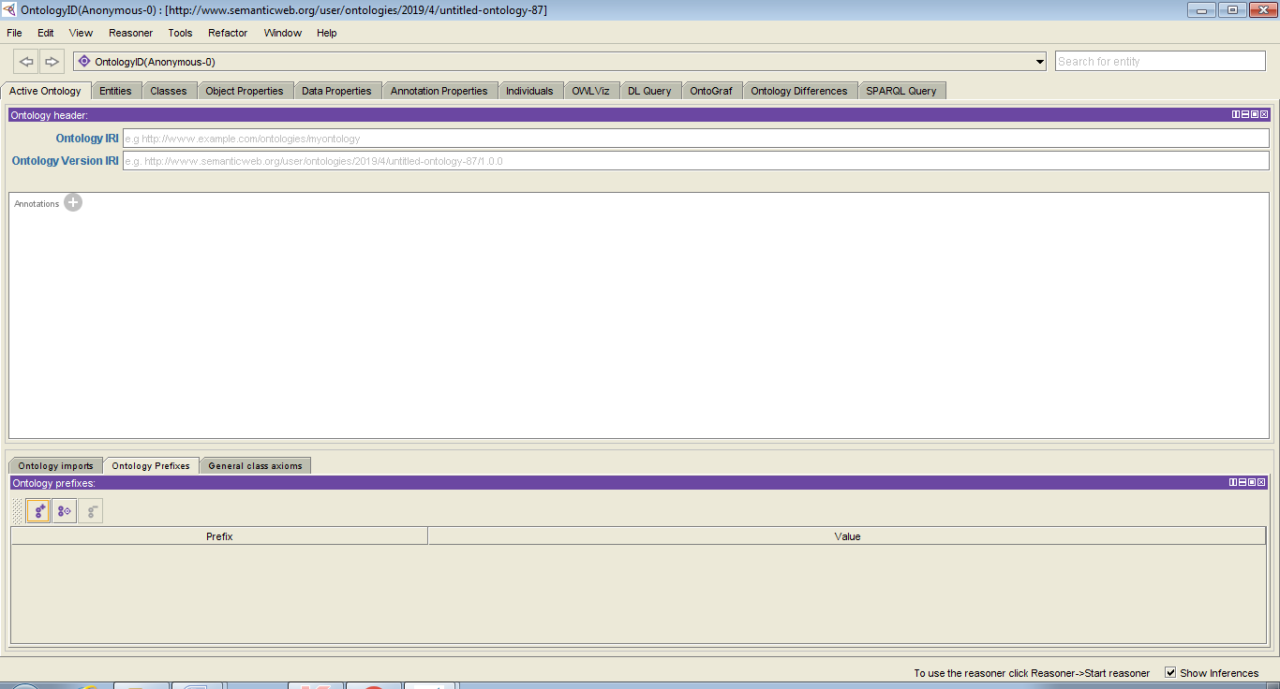

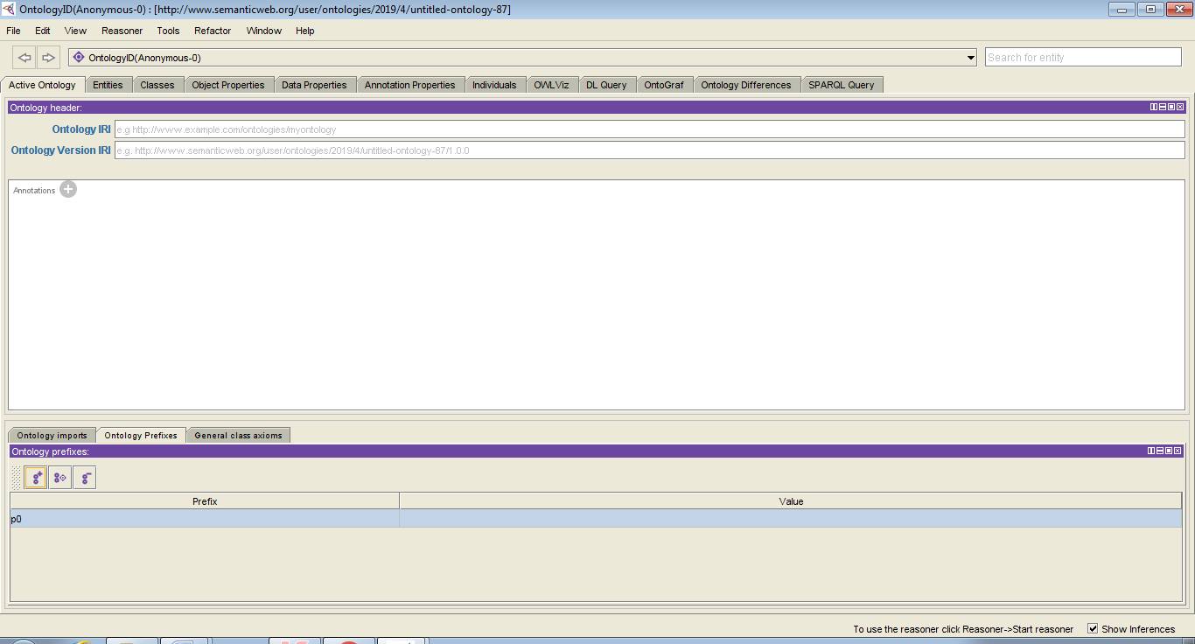

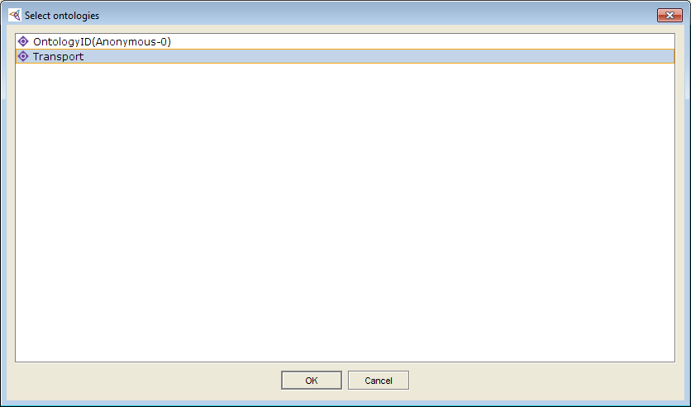

Step 4: prefix value is getting as shown in the below screen

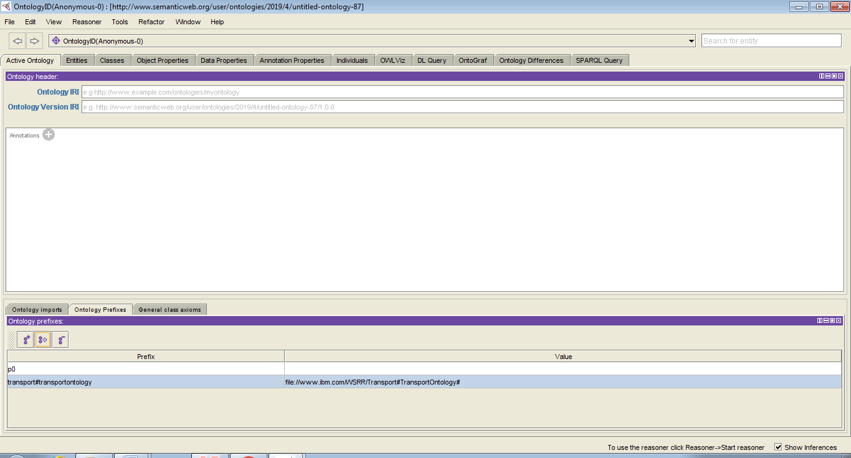

Step 5: give the prefix value in ontology IRI as shown in the below screen

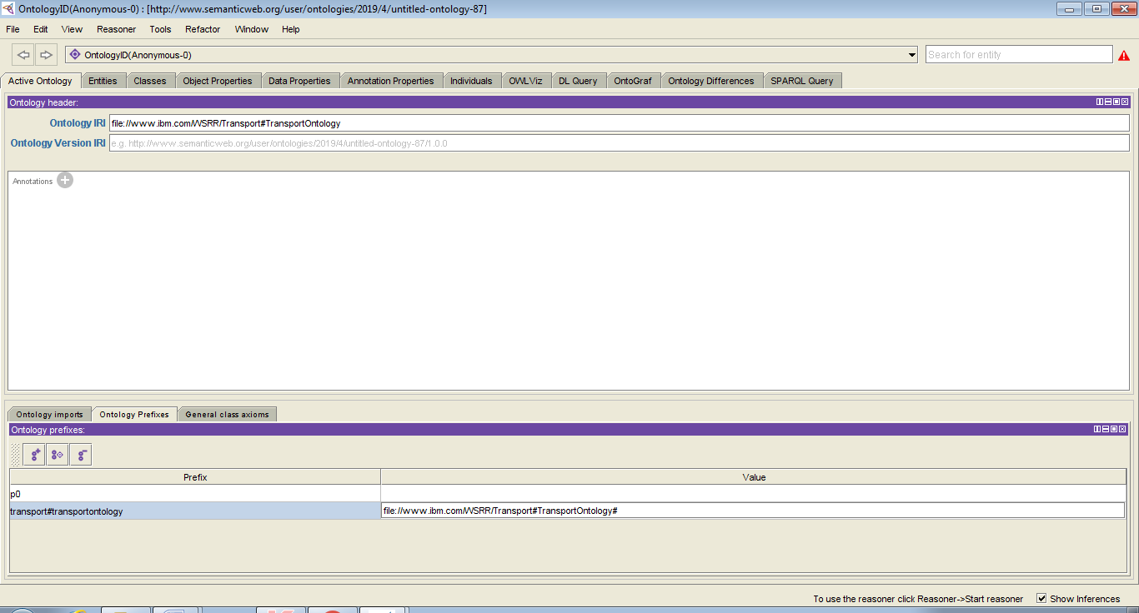

Step 6: Click on the Entities Button in protégé tool as shown below screen.it display the class hierarchy of given input

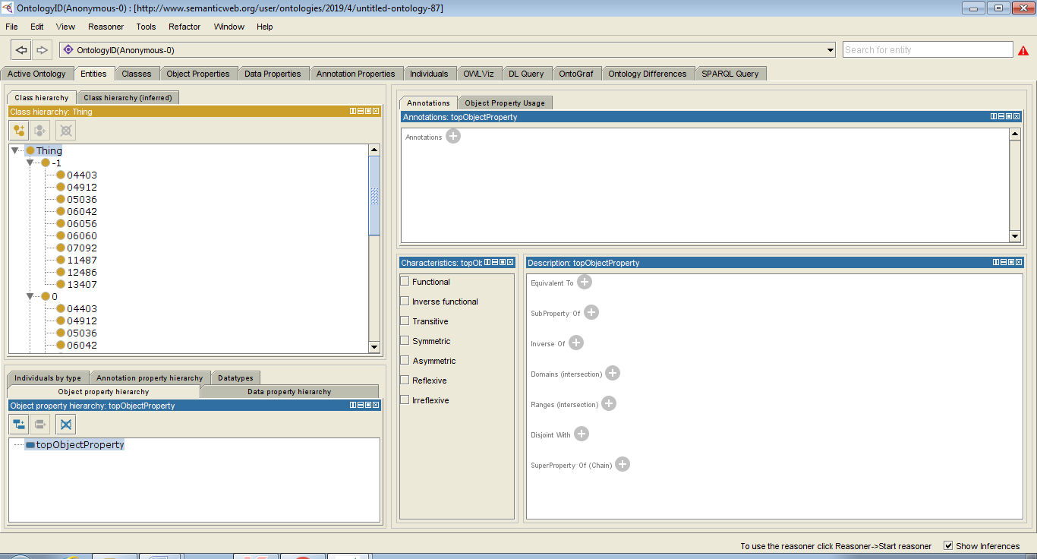

Step 7: Click on the Classes Button in protégé tool as shown below screen. it display the class hierarchy of given input

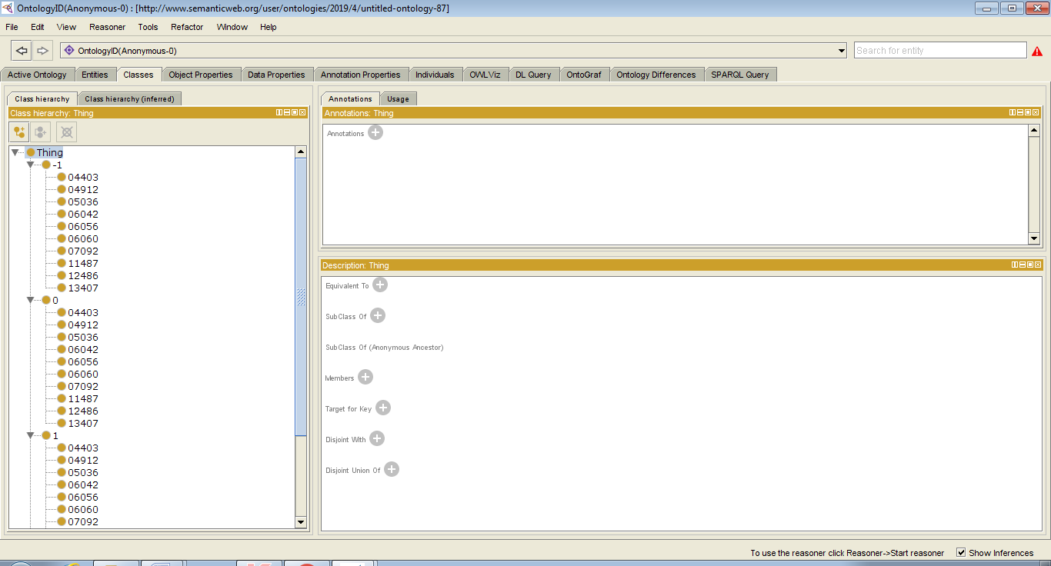

Step 8: Click on the OntoGrafButton in protégé tool as shown below screen. it display the total hierarchy of given input

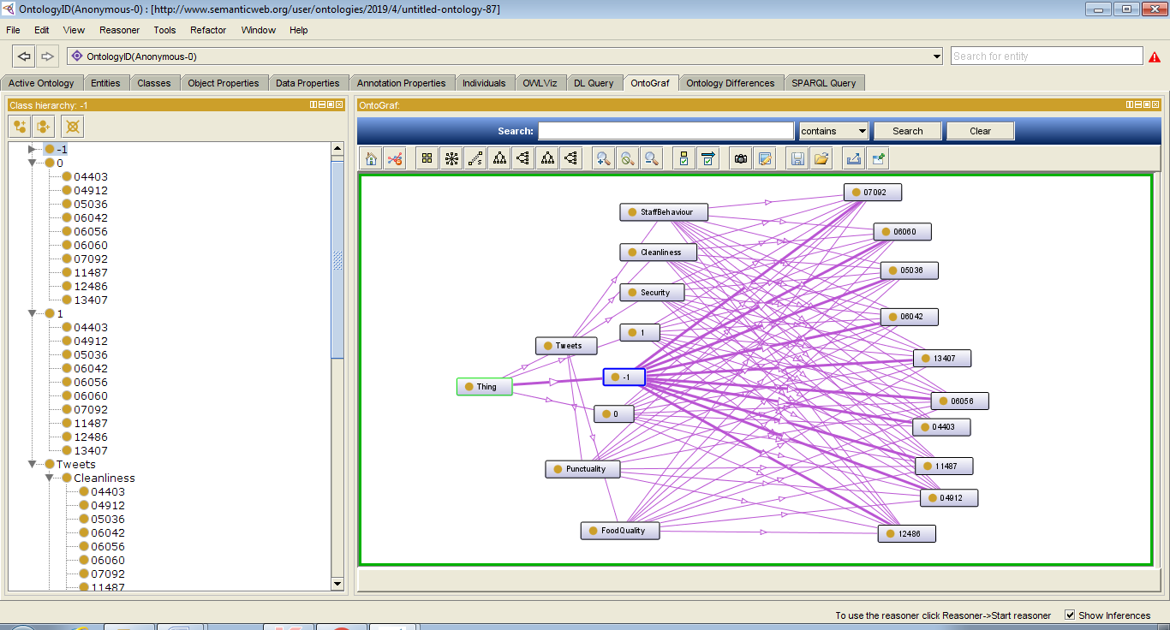

Step 9: Click on the SPARQL Query in protégé tool as shown below screen.

